FULL STACK DEVELOPMENT

Full stack development refers to the development of both front end and back end portions of an application. This web development process involves all three layer- Presentation layer(front end part that deals with the user interface), Business Logic Layer(back end part that deals with data validation) and the database Layer.

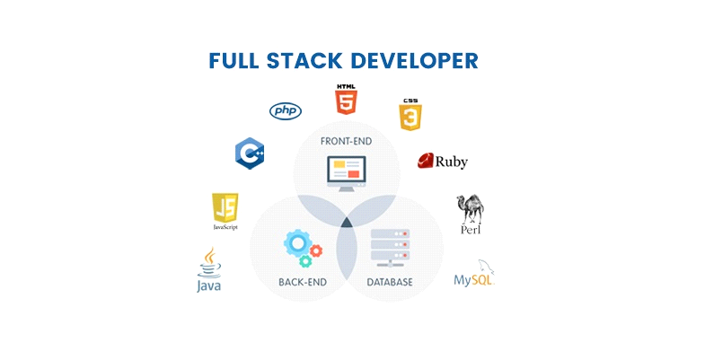

A full stack development tell how to design and develop complete websites,Mobile Applications from start to finish

**TECHNOLOGIES USED :**

* **Front end-** HTML, HTML5, JavaScript, J Query, CSS3
* **Backend-** Python, PHP, Angular2, NodeJs,GO
* **Database-** MySQL, MongoDB, CouchDB
* Deploy code on AWS EC2 with Apache2 or Nginx as a web server